The Adventures of Tom Sawyer

Chapter Five:
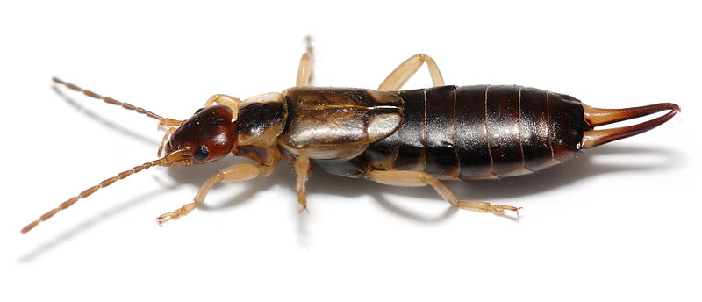
Please use your best descriptive writing to describe this bug. Tom refers to it as a “pincher bug” but it really is called an earwig.
____________________________________________________________________________
____________________________________________________________________________
____________________________________________________________________________
____________________________________________________________________________
____________________________________________________________________________
____________________________________________________________________________
____________________________________________________________________________
____________________________________________________________________________
____________________________________________________________________________
____________________________________________________________________________
____________________________________________________________________________
____________________________________________________________________________
____________________________________________________________________________
Chapter Five Comprehension Questions:
- What treasure did Tom bring out during the sermon?
________________________________________________________________________
- Do you think that people should be allowed to laugh whenever they think something is funny?
________________________________________________________________________
________________________________________________________________________
________________________________________________________________________

Illustrate a scene from Chapter Five below:

